#### Super user Dashboard

1. In the customers view, make the table wider so that all the columns can be seen.
2. In the customers view, add column sorting.

#### "Contact us" form:

1. Legal Entity tab: add field for Contact person name.
2. Change Email wording to the following, when the client has completed the form:

*"Dear Customer,*

*Thank you for your inquiry. Our team is currently processing your request and will get back to you as soon as possible.*

*We appreciate your interest and look forward to assisting you.*

*Best regards,*

*Finakey Onboarding Team"*

1. Change email wording to the following, when the client has been accepted to start de onboarding process:

*"Dear Customer,*

*We are pleased to begin the onboarding process with you.*

*To get started, please set your password by clicking the button below:*

*[Set Password Button]*

*Thank you for choosing Finakey. We look forward to assisting you through the onboarding process.*

*Best regards,*

*Finakey Onboarding Team"*

#### In reset password page:

1. *Change de the text "Reset password" to "Set password".*
2. *"Change Email wording for password reset:*

*Dear customer:*

*You are receiving this email because you requested a password reset for your account.*

*This password reset link will expire in 24 hours.*

*If you did not request a password reset, no further action is required.*

*Regards,*

*Finakey Onboarding Team"*

1. *Change the 1440 minutes expire time for 24 hours in the project.*

#### Individual Onboarding Page CLIENT SIDE:

1. Eliminate from clients Dashboard the last two columns (reviewed by rm and reviewed by swisscomply), they don’t need to see this. Also eliminate the number of forms (only for internal use).
2. Move the reject reason message to the column of completed by client.
3. Change table viewed by prospect client as per following:

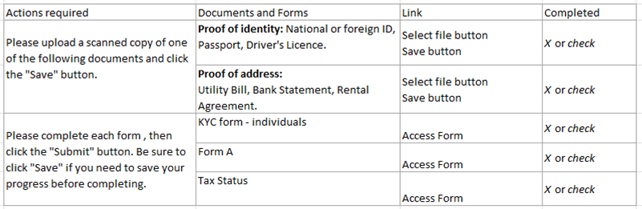

#### Individual Onboarding Page Staff side:

1. After approved by Manager (super user), trigger an email to user of type Swisscomply saying:

- "You have been assigned a new prospect for your review and validation."

1. Send an email to RM and cc Management (super users) when an Swisscomply user Validated or Rejected a client saying:

- "There is a prospect client validated by Swisscomply for your review.". A client is validated when all of their documents are accepted.

1. Replace column name Action by Accept.
2. Add column for Approved by Management.

- In this column, the Manager (super user), have to doing validation or rejection of the document or form, exactly as the RM, setting the formfield a new state 3, validated by Manager.

1. Change Swisscomply column to: Validated by Swisscomply.

- In this column, the Swisscomply user type, have to doing validation or rejection of the document or form, exactly as the RM and Manager, setting the formfield a new state 4, validated by Swisscomply .

1. Add: a column at the end named "Finalized Documents and forms" for signature where the PDF icon appears for client to print, sign and upload.

- The pdf icon has to be moved to this column. The user download the pdf, signs it, scan and upload the document in this column.

- Add the button with Choose file to upload

1. Add: a column to right with all the download process in order to make them available to RM for printing and filing. This columns have to content only a link to the document signed and uploaded in the previous column.
2. Final design:

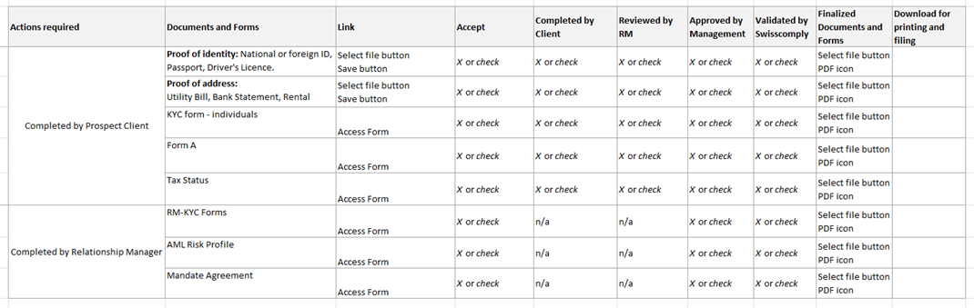

#### Repeat the step 5 with the dashboards of the rest of legal figures: corporate, trust, foundation and charity.

Test mail on local.

Run MailHog_windows_386.exe

[http://localhost:8025/](http://localhost:8025/#)

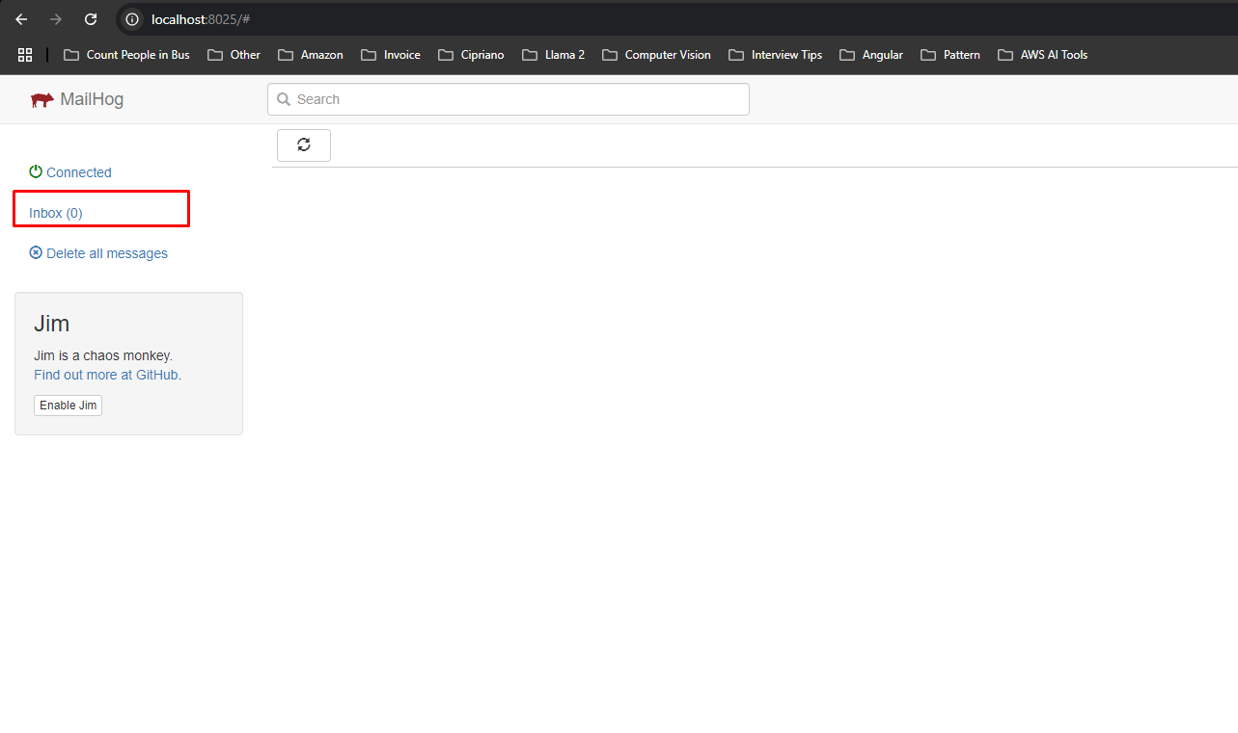

Then you will see this page. If you send email, the email will be shown on this page.

- Setting mail configuration in .env file

MAIL_MAILER=smtp

MAIL_HOST=127.0.0.1

MAIL_PORT=1025

MAIL_USERNAME=null

MAIL_PASSWORD=null

MAIL_ENCRYPTION=null